**Information System Management Lab**

**BCOM 307**

**Assignment #11**

***Submitted by:***

**Name:** YASH JAIN

**Enrollment No:** 03914788818

**Semester:** B.Com(H) 5th Semester

**Class:** B.COM(H)

**Section:** B.Com 5A

**Date of Submission:** 04/10/2021

***Submitted to:***

**Praveen Kumar Singh**

**Assistant Professor, MAIMS**



**Department of Commerce**

**Maharaja Agrasen Institute of Management Studies**

**Affiliated to Guru Gobind Singh Indraprastha University, Delhi**

**Sector -22, Rohini, Delhi -110086, India; www.maims.ac.in**

Maharaja Agrasen Institute of Management Studies

Affiliated to GGS IP University; Recognized u/s 2(f) of UGC Recognized by Bar Council ofIndia; ISO 9001: 2015

Certified Institution Sector 22, Rohini, Delhi -110086, India; [www.maims.ac.in](http://www.maims.ac.in/)

Department of Commerce

Academic Year: 2020-21

Semester: Vth

# Assignment No.11

# Unit No:

**Course/Subject Code:** BCOM 307 **Subject Title: Information System Management Lab**

# Issue Date: Last Date of Submission:

**Instructions for Students:**

# All Questions are Compulsory.

1. The student should attach proper cover page for each assignment clearly mentioning the Assignment No.
2. Each assignment should be prepared by the student individually with proper explaination and screenshots.
3. A4 size ruled sheets should be used for the assignment.
4. Assignment pages should be serially numbered at the bottom of page.

***During online education mode, upload scanned copy of the complete assignment including cover page latest by due date.***

|  |  |  |
| --- | --- | --- |
| **Question No.** | **Question** | **CO No.** |
| 1 | Drop the City Column from Client_Master table. | **CO1, CO2, CO3** |
| 2 | Change the column 'Name' size to 35. |
| 3 | Change the name of table 'client_master' to clients. |
| 4 | Create a table temp, insert 3 values and Truncate table in the database. |
| 5 | Delete the table temp from the database. |

**ASSIGNMENT 11 - ALTER COMMAND III**

**Task 1 : Drop the City Column from Client_Master table**

This task can be completed using the **‘alter’** command, with the **‘drop’** keyword. The DROP Keyword is used to delete a column from the table. The syntax for this is -

Alter table <tablename> drop column <columnName>;

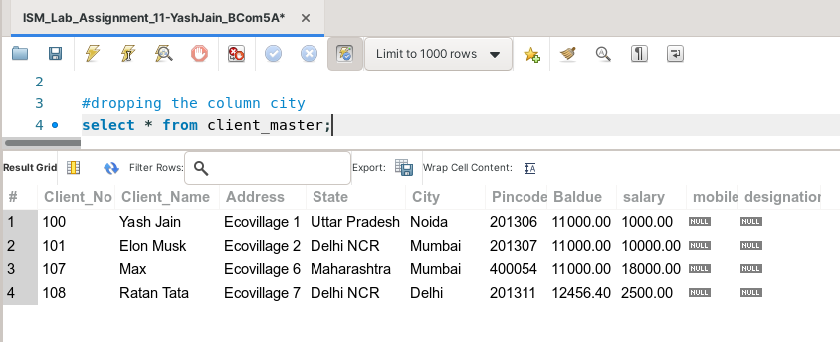

(before dropping city column)

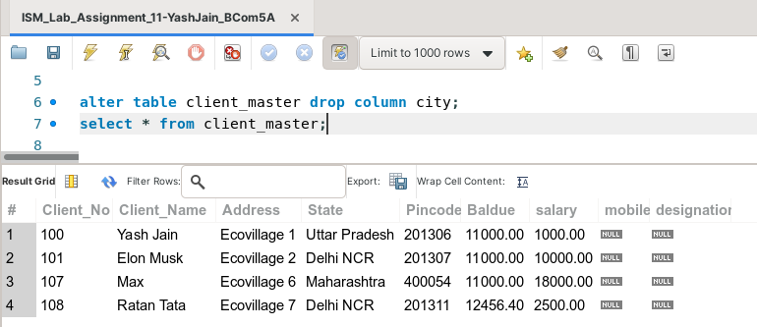

(after dropping city column)

**Task 2: Change the column 'Name' size to 35.**

This task can be completed using the **‘Alter’** command, with the **‘modify’** keyword. MODIFY keyword is used to modify the column metadata in a table like data type and size. We cannot modify the constraints of the column via this keyword. The syntax for this is -

Alter table <Tablename> modify <columnname> <new datatype> (<new size>);

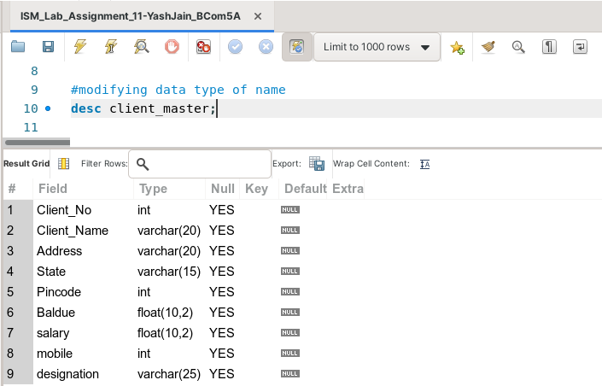

(before modifying the size of ‘name’ column)

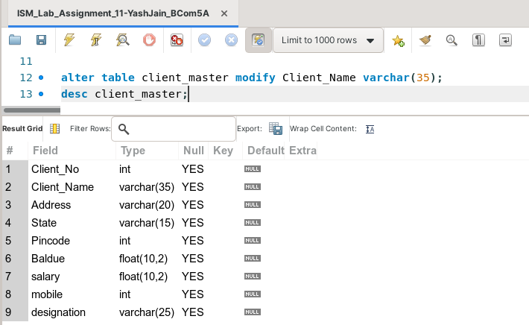

(after modifying size of ‘name’ column)

**Task 3: Change the name of table 'client_master' to clients.**

This task can be completed using the **‘rename’** command along with the **‘TO’** keyword. The RENAME Command is used to rename the table. The syntax for this is -

Rename table <tablename> to <newtablename>;

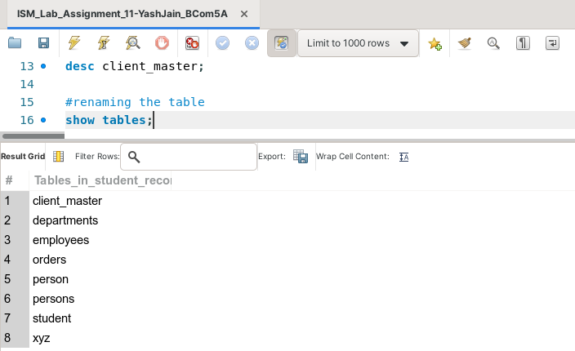

(before renaming the table)

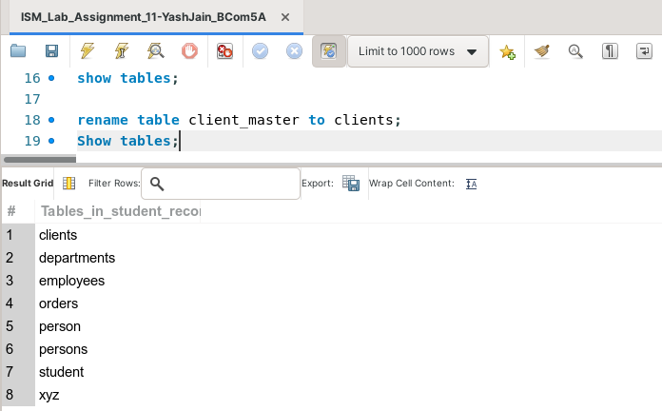

(after renaming the table)

**Task 4: Create a table temp, insert 3 values and Truncate table in the database.**

The following task is completed using the **‘create table’** command, along with the **‘insert into’** command with the **‘values’** keyword, and finally, the **‘truncate’** command.

Truncate Table empties the table completely. It is different from DELETE command, as it deletes and re-creates the table (which is faster than deleting entries individually). These operations are not transaction-safe. The number of deleted rows are not returned in truncate. The syntax for this is -

Truncate table <tablename>;

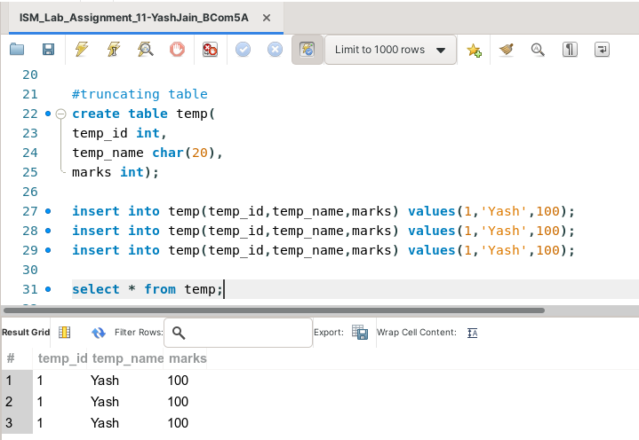

(before truncating table)

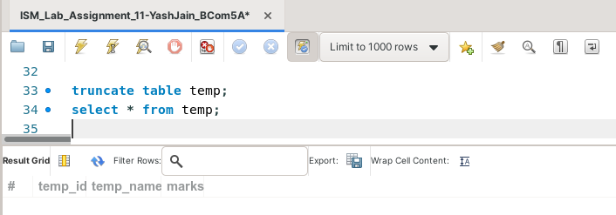

(after truncating table)

**Task 5: Delete the table temp from the database.**

This task can be completed using the **‘drop table’** command. Drop Table is used to delete the table from the database. The syntax for this is -

Drop table <tablename>;

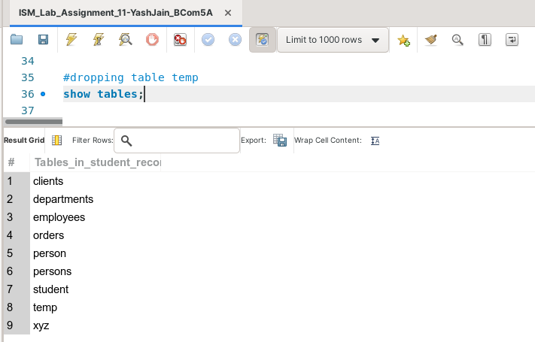

(before deletion)

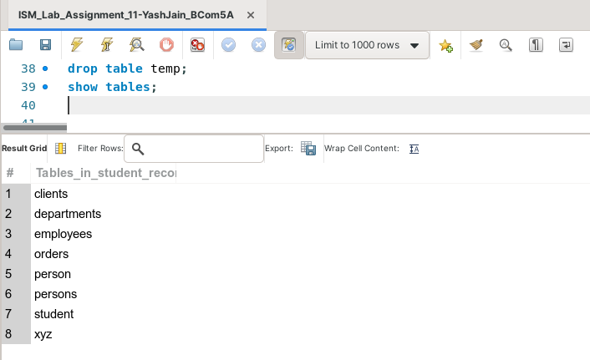

(after deletion)